**NAME:TASMIYA FATHIMA**

**USN:1BM19CS172**

**PROGRAM-3(SUPPLIER DATABASE)**

**QUERIES**

create database Supplier;

use Supplier;

create table Suppliers(

sid varchar(20) ,

sname varchar(20),

city varchar(20),

primary key(sid)

);

desc Suppliers;

create table Parts(

pid integer,

pname varchar(20),

color varchar(20),

primary key(pid)

);

desc Parts;

create table Catalog(

sid varchar(20),

pid integer,

cost real,

primary key(sid,pid),

foreign key(sid) references Suppliers(sid),

foreign key(pid) references Parts(pid)

);

desc Catalog;

insert into Suppliers values(10001,'Acme Widget','Bangalore');

insert into Suppliers values(10002,'Johns','Kolkata');

insert into Suppliers values(10003,'Vimal','Mumbai');

insert into Suppliers values(10004,'Reliance','Delhi');

select *from Suppliers;

insert into Parts values(20001,'Book','Red');

insert into Parts values(20002,'Pen','Red');

insert into Parts values(20003,'Pencil','green');

insert into Parts values(20004,'Mobile','green');

insert into Parts values(20005,'Charger','Black');

select *from Parts;

insert into Catalog values(10001,20001,10);

insert into Catalog values(10001,20002,10);

insert into Catalog values(10001,20003,30);

insert into Catalog values(10001,20004,10);

insert into Catalog values(10001,20005,10);

insert into Catalog values(10002,20001,10);

insert into Catalog values(10002,20002,20);

insert into Catalog values(10003,20003,30);

insert into Catalog values(10004,20003,40);

select *from Catalog;

select distinct P.pname from Parts P, Catalog c where P.pid=C.pid;

select S.sname from SUPPLIERS S where not exists (select P.pid from PARTS P where not exists (select C.sid from CATALOG C where C.sid = S.sid and C.pid = P.pid));

select S.sname from SUPPLIERS S where not exists (select P.pid from PARTS P where P.color = 'Red' and (not exists (select C.sid from CATALOG C where C.sid = S.sid and C.pid = P.pid)));

select P.pname from PARTS P, CATALOG C, SUPPLIERS S where P.pid = C.pid and C.sid = S.sid and S.sname = 'Acme Widget' and not exists (select * from CATALOG C1, SUPPLIERS S1 where P.pid = C1.pid and C1.sid = S1.sid and S1.sname <> 'Acme Widget');

select distinct c.sid from Catalog c where c.cost >(select avg(ca.cost) from Catalog ca where ca.pid=c.pid);

select s.sname ,p.pid from Suppliers s, Catalog c, Parts p where s.sid=c.sid and c.pid =p.pid and c.cost=(select max(ca.cost) from catalog ca where ca.pid=p.pid);

**SCREENSHOTS OF QUERIES**

**Suppliers table:**

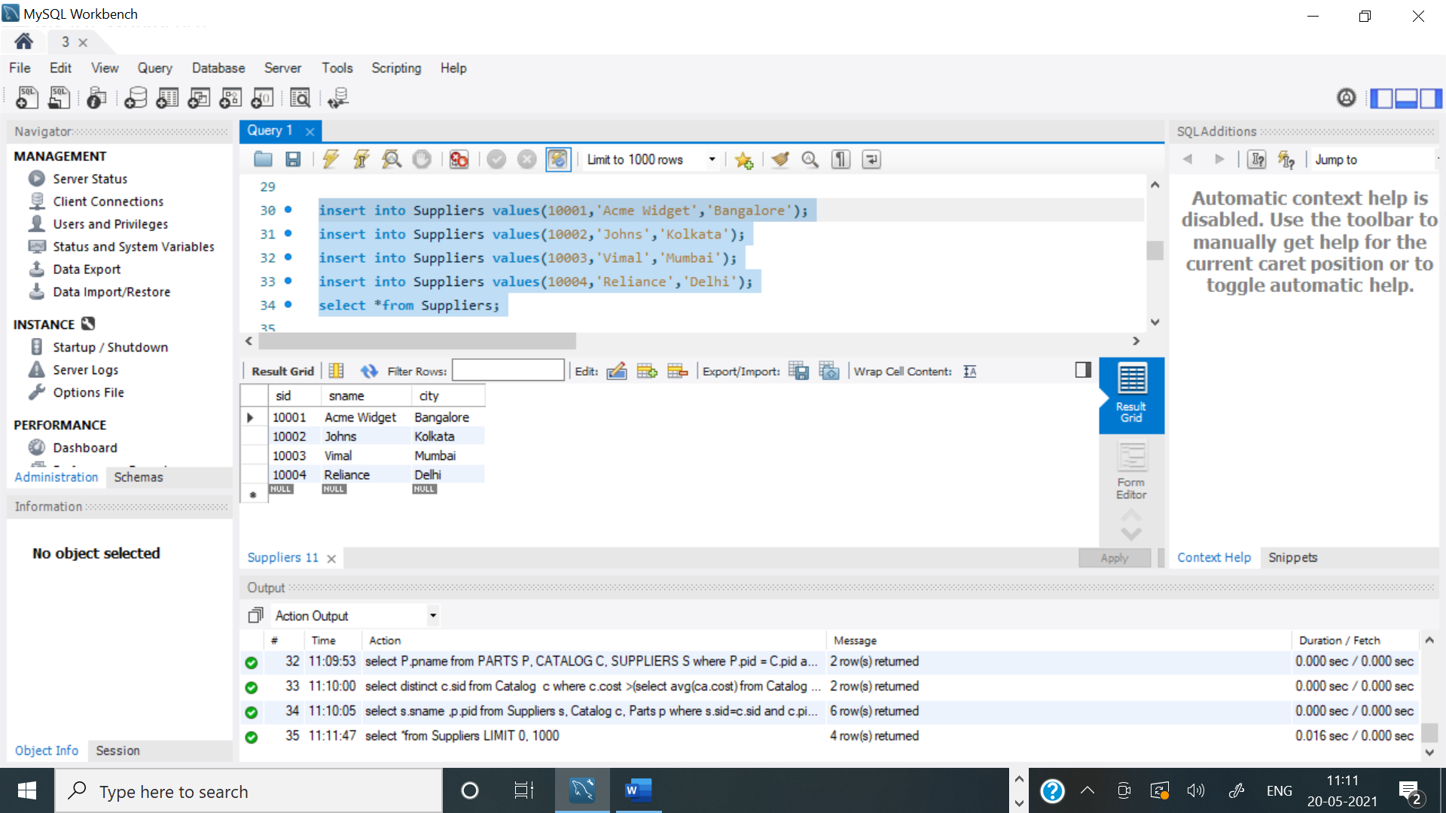

**Parts table:**

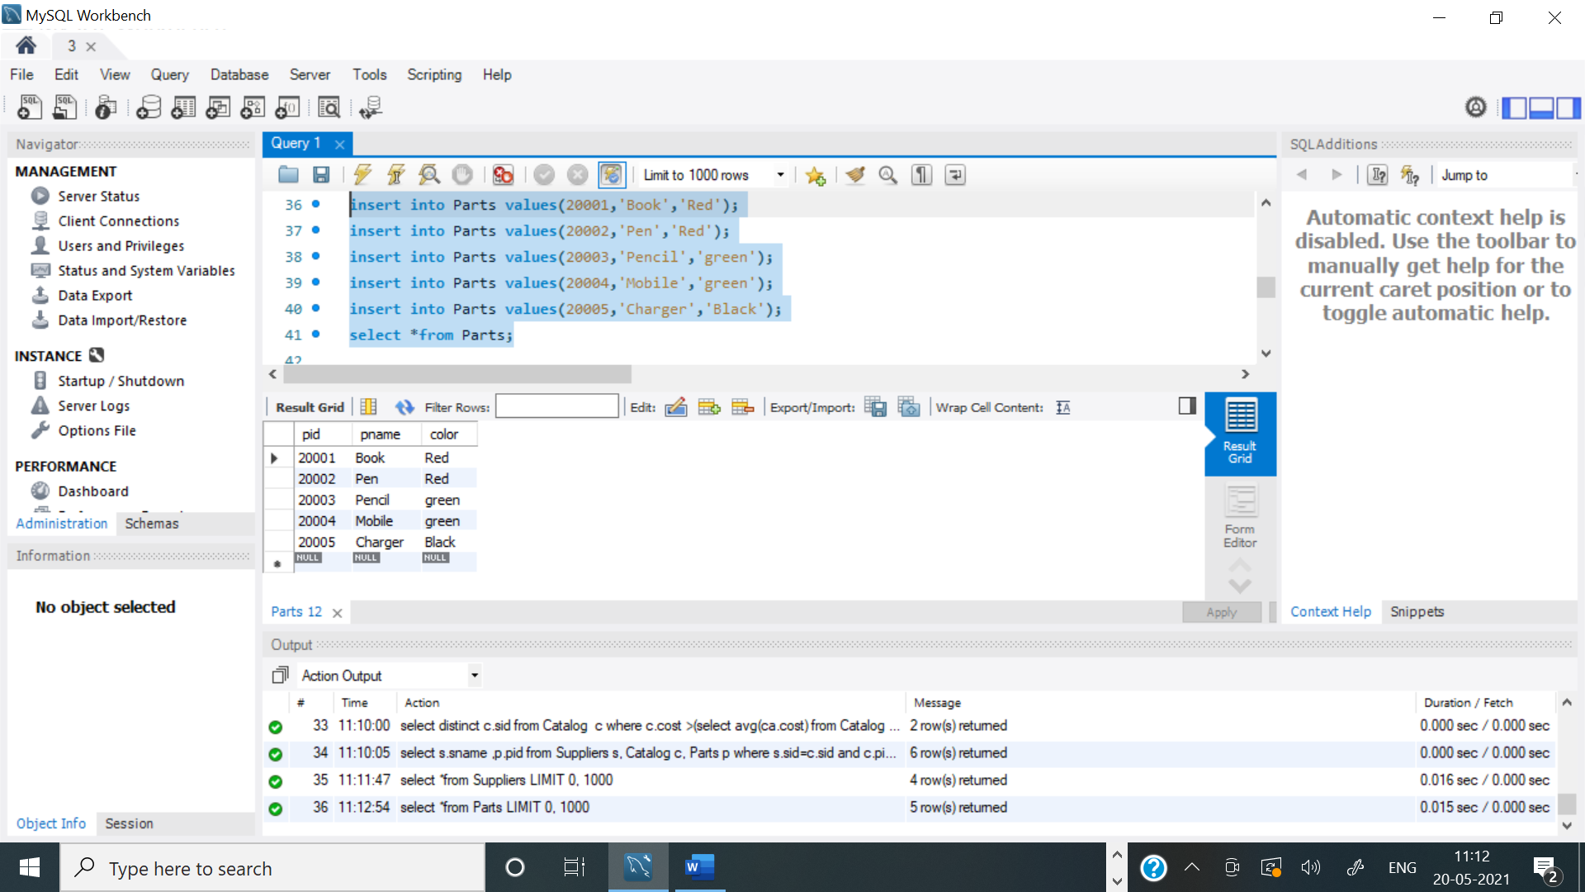

**Catalog table:**

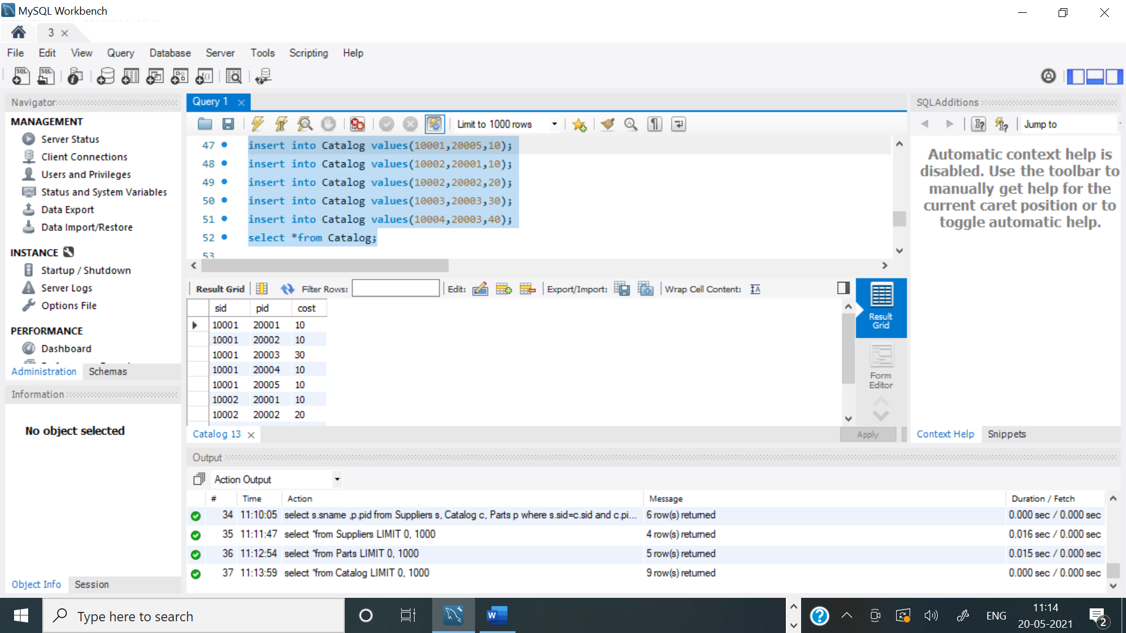

**Query 3:**

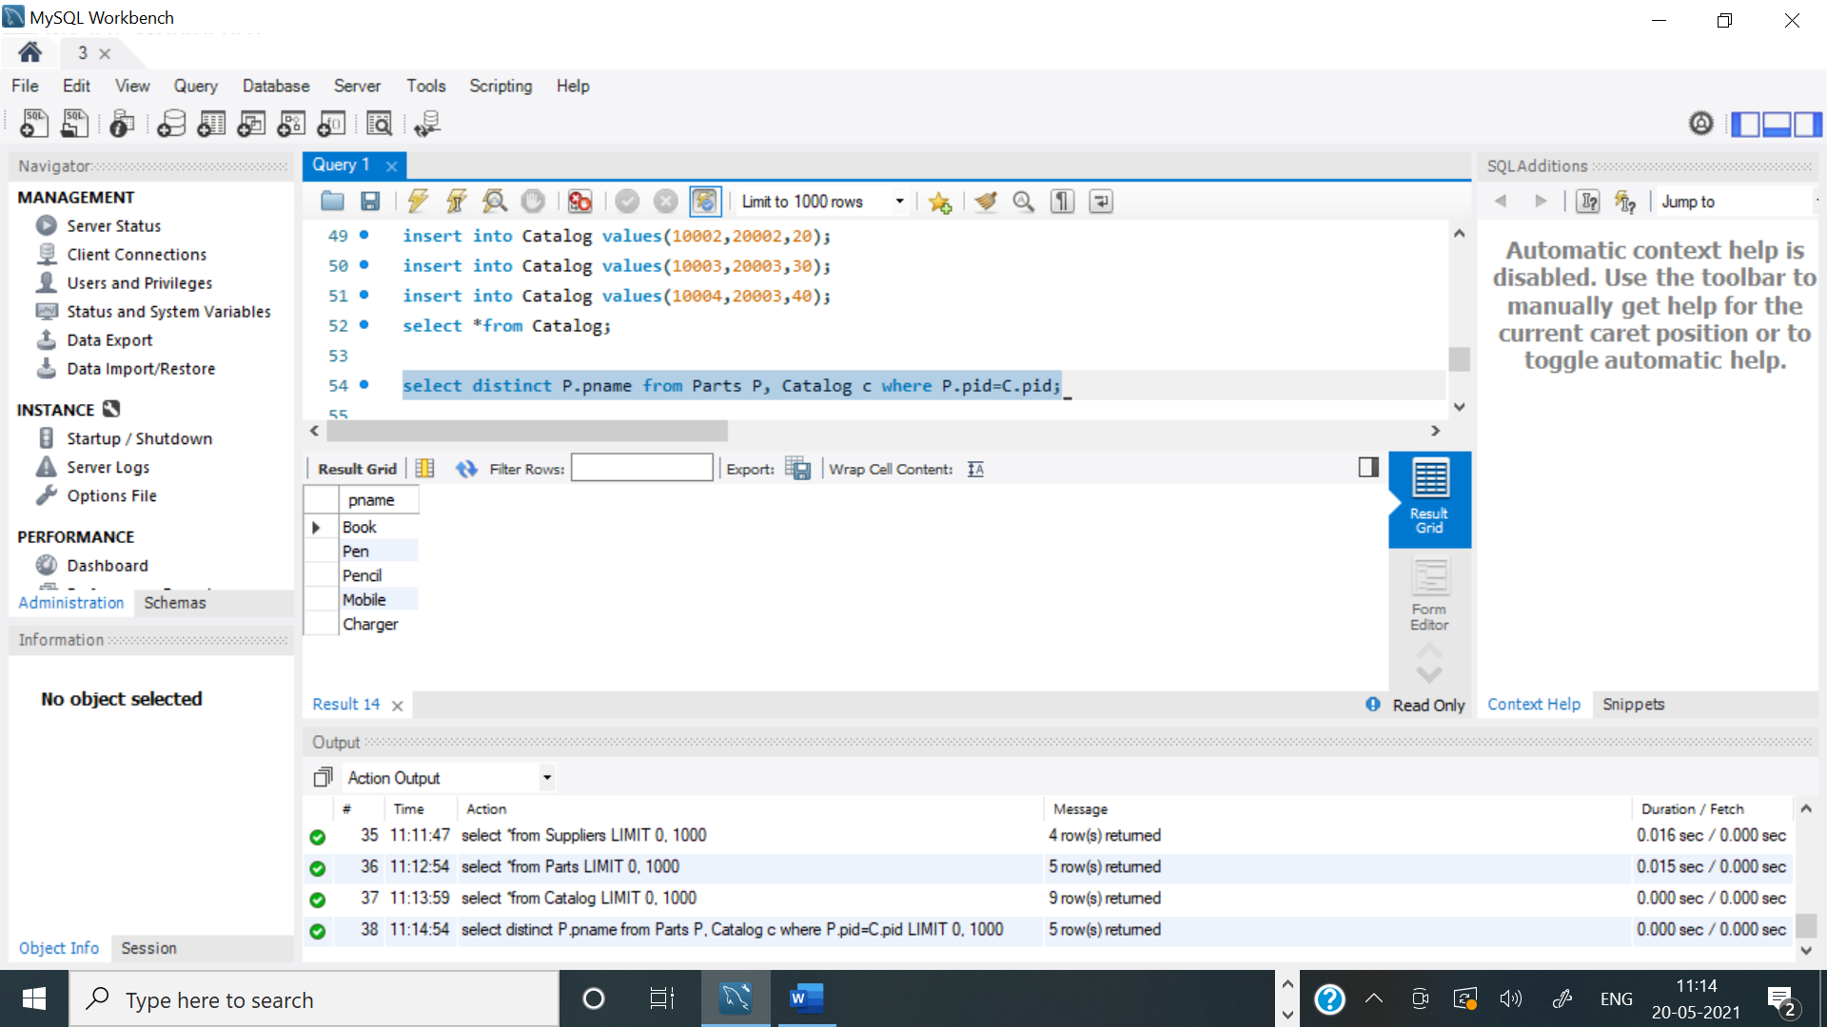

**Query 4:**

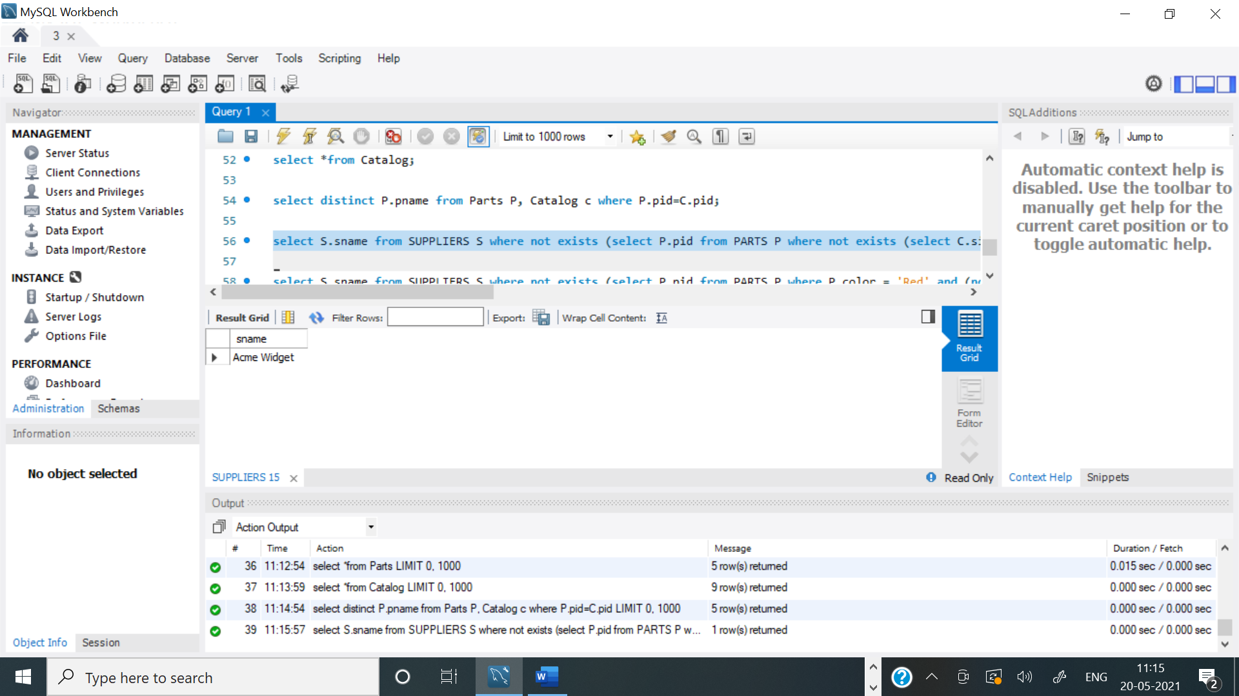

**Query 5:**

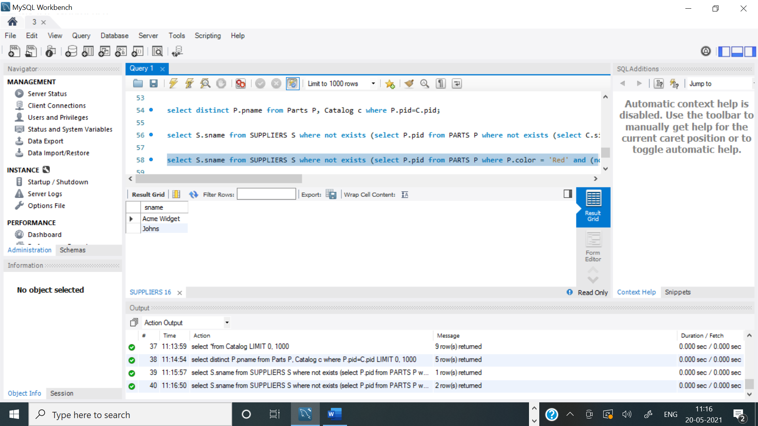

**Query 6:**

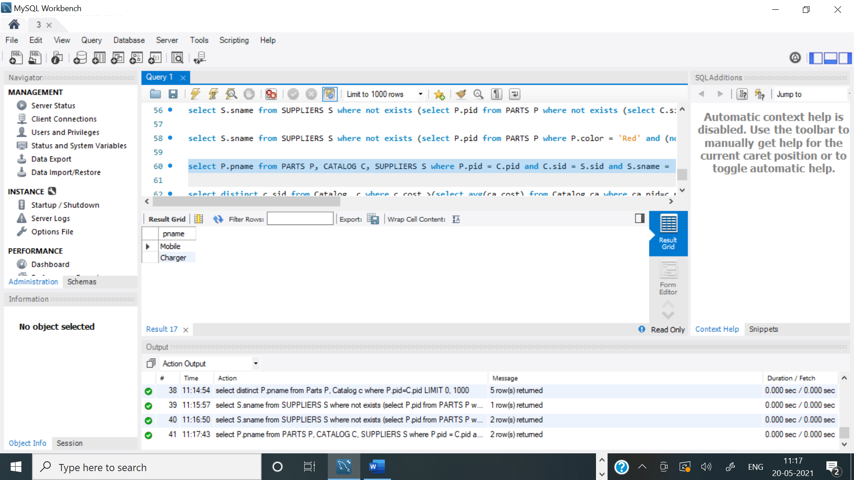

**Query 7:**

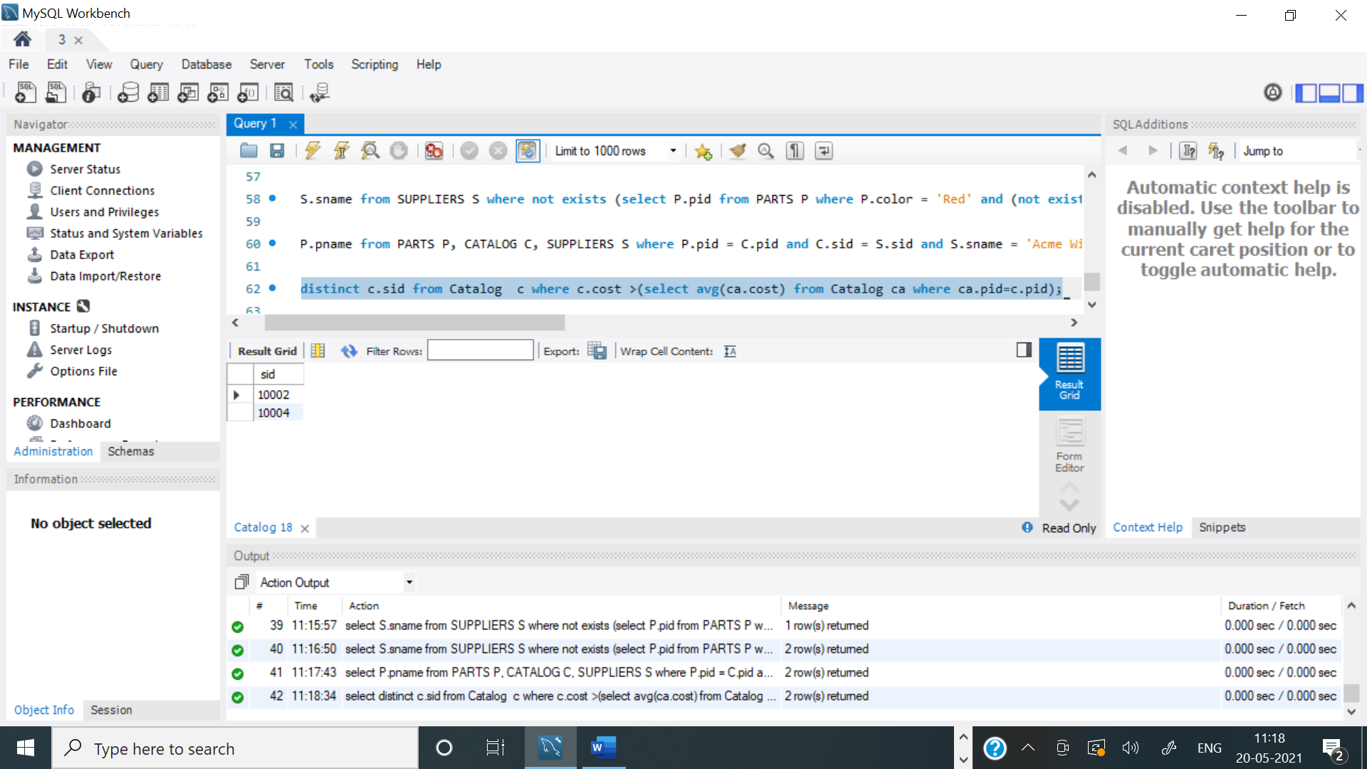

**Query 8:**

